What is Polymorphism?
Polymorphism is an object-oriented programming principle that allows objects of different classes to be treated as objects of a common base class, while still behaving according to their specific derived class implementation. The word “polymorphism” literally means “many forms,” and in programming it refers to the ability of a single interface or method call to represent different behaviors depending on the object type at runtime. In practice, this means you can call the same method on different objects and get different results without needing to know the exact class of the object. Polymorphism is commonly achieved through inheritance and method overriding, where a base class defines shared behavior and derived classes provide their own specific implementations. This enables flexible, extensible, and maintainable code.
Why Polymorphism is important?
One of the most important benefits of polymorphism is that it makes software easier to extend and maintain. By programming against a base class or interface instead of concrete implementations, developers can add new functionality with minimal impact on existing code. In the Eternal Quest program, the GoalManager does not need to know whether it is working with a SimpleGoal, EternalGoal, or ChecklistGoal. It simply interacts with objects of type Goal. This reduces tight coupling and eliminates the need for large conditional statements to determine behavior. Polymorphism also improves readability and scalability because new goal types can be added by creating a new derived class without modifying core logic, which follows the Open/Closed Principle in software design.
Application of Polymorphism in the Program
Polymorphism is applied throughout the Eternal Quest program in how goals are stored and processed. All goals are stored in a single list of type List<Goal>, even though each goal behaves differently. When the program records an event, it calls the RecordEvent() method on a Goal reference. At runtime, the correct version of the method is executed depending on whether the object is a SimpleGoal, EternalGoal, or ChecklistGoal. This allows the program to award points correctly, handle bonuses, or determine completion without needing to check the goal type explicitly. This real-world application demonstrates how polymorphism allows diverse behaviors to be handled uniformly through a shared interface.
Code Example Demonstrating Polymorphism
Below is a direct example from the Eternal Quest program that demonstrates polymorphism in action:

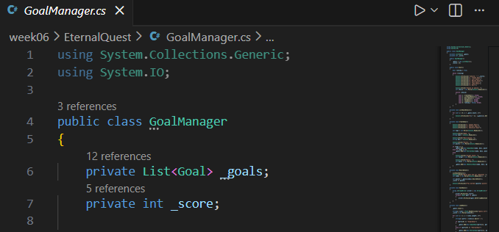
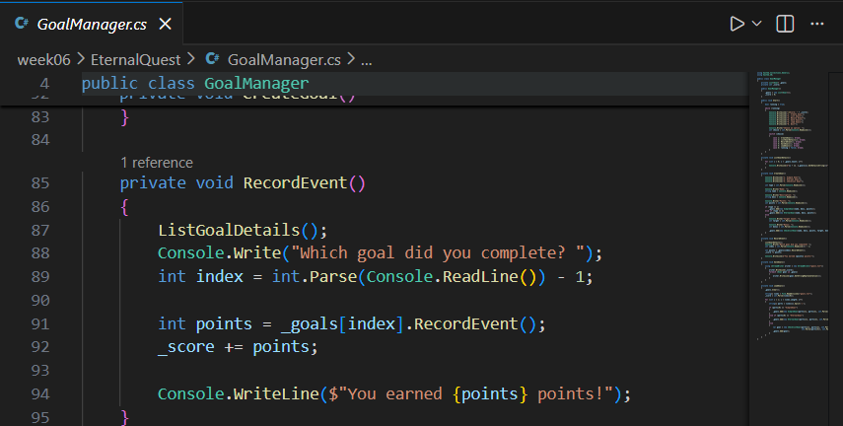
Although _goals[index] is of type Goal, the RecordEvent() method that runs depends on the actual object stored in the list. For example, calling RecordEvent() on a SimpleGoal marks it complete and awards points once, while calling it on a ChecklistGoal increments progress and may award a bonus. The GoalManager does not need to know which specific type it is working with—polymorphism ensures the correct behavior is selected at runtime. This makes the code clean, flexible, and easy to extend.

